Excel Assignment – 9

**Q1. See the below picture and create the exact table with exact formatting.**

Font – ‘Times New Roman’ Size – 14, Colour of first line Orange.

**Q2. From the above table use Sum Formula and find the total for each student.**

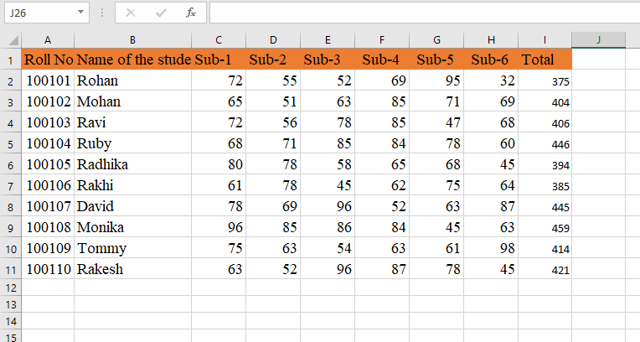

**Q3. Calculate Average for each student in the next row. Use Formulas.**

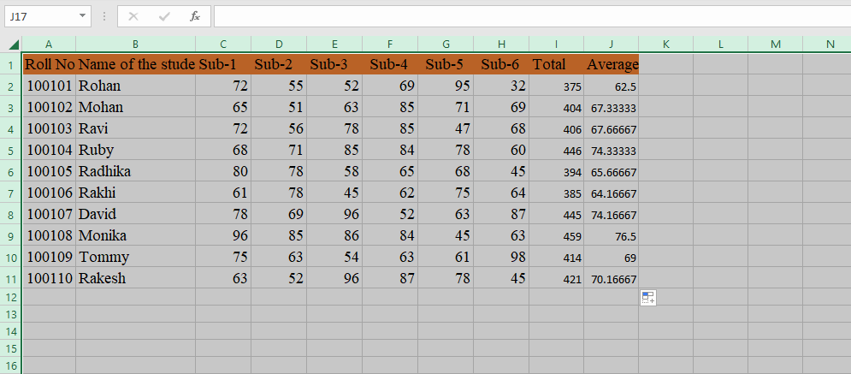

**Q4. Calculate Rank for each student. Use Formulas.**

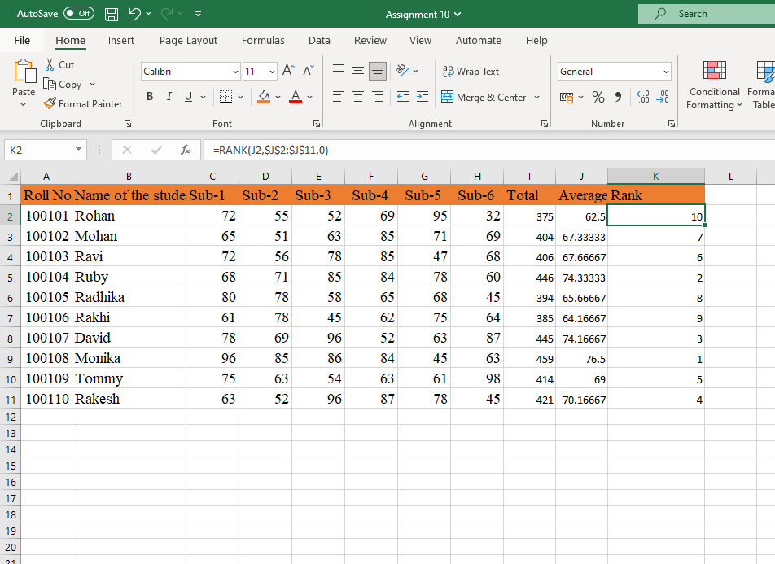

**5. Calculate Percentage for each student. Use Formulas. Round off the**

**decimals up to 2 points**.

